Online Auctioning

User Manual

**Slippery Rock University**

Fall 2024

Griffin Vasalani – glv@sru.edu

Grant Riley – [gwr1002@sru.edu](mailto:gwr1002@sru.edu)

Jayden Williams – [jsw1015@sru.edu](mailto:jsw1015@sru.edu)

1. Introduction

Welcome to Offerly! This social marketplace app offers a wide range of features, including buying products, making deals and offers, discussing trends, messaging friends, and creating groups to share experiences. The inspiration behind this project stems from the need for a modern platform that enables communities to exchange goods and services. This manual is designed to guide both future users and developers through the general flow and design of the platform.

To get started, please refer to the Installation Manual located in the documents folder. Once you’ve successfully installed the app, consult the Login Manual to access your user account. We look forward to helping you explore everything Offerly has to offer in the following sections.

1. Index Page

The landing page for our website begins on the browsing page. Here, you can view some of the products for sale with information on the seller, price, and quantity available. You can navigate through the listings by page, set filters to view certain products, or type the name or keyword of a product you are looking for. For now, however, you will need to be signed in to view listings further. 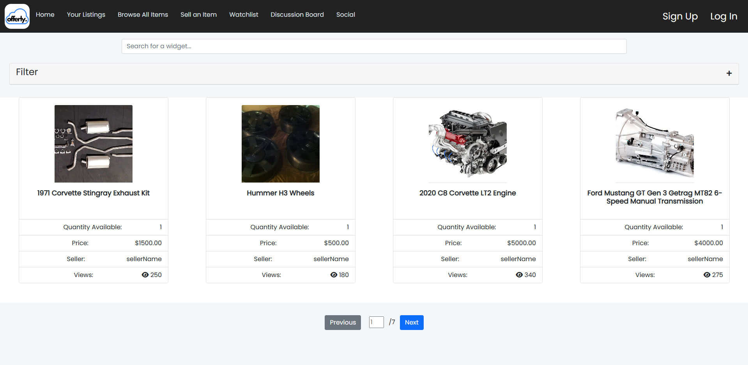

At the top of every page on our website, a navigation bar is present. From the nav bar you will see a list of activities and pages you can interact with. Some of the tabs will prompt you to sign in. You can sign up or sign in anytime.



Navigate to the Log In button now!

1. Login/ Sign-Up Page

The home tab, or login page allows you to sign in or create a new account. You can use one of the default accounts from the Login Manual or create a new user here. If you forgot any of your information, there are forms to help you get back on track.

To create a new personal account, click the sign-up link at the bottom of the page.

You will need to make a username and password and enter in your personal information such as email, and phone number. There are security questions in place to help recover your account if you forget your login info. For security purposes, you will be asked to enter the CAPTCHA to verify your account. To do this, you must type the sequence of letters and numbers you see in the box above.

You may choose to enter in your address and payment information now but are not required to do so. However, if you want to make a purchase, that information will be needed. You can update your information anytime by clicking on your username located on the Nav Bar and selecting the appropriate category in the drop-down menu. There is also a preferences button to update what your interests are when you browse the site. You can also sign out from here.

Once you make an account, you will be asked to verify your email. You can do this by signing into your personal email and clicking the link in the email from Offerly. You will need the verification code and the username associated with the account.

Once verified you are ready to start exploring all Offerly and all it has to offer!

1. Home Page

This page shows you all the for most items offered on the site and is dynamically updated and changed based on your preferences as a user. The most popular items are shown at the top based on the number of views each item has. The items with the most views appear at the top. Also, each section is clearly shown with the auto section appearing under, with only auto related items, and so on for each category of items.

1. Your Listings Page

Once you become a renowned merchant on Offerly, managing all your listings might prove to be difficult. This webpage will help traverse your market with ease. This provides a more detailed account of all the products you are selling and have sold.

Clicking on each individual listing gives a view count, watchlist count and a way to navigate to the listing, to inform you of all the latest trends.

1. Market Listing Page

When viewing listings on the browse page, you can click on the listing icons to view more details on the corresponding listing. From that listing page, there are several options available to you.

If you are interested in the product, you can view the seller's information, message them, add the item to your watchlist or make an offer. When you make an offer, a notification will be sent to the seller, and the notification will appear in the notification bell tab in the top of the nav bar. The seller can then make a counteroffer or accept the offer. If an offer has been accepted for a product the listing will state that it's in a temporarily pending state. Only the user with an accepted offer may purchase the listing.

If you are selling a product, you can update/delete, or accept/reject offers, or send counter offers on the listing page at any time. If you accept an offer, the listing page will be put into a temporary pending state. You will not be able to modify the listing during this time.

1. Sell an Item

To create a new listing and start selling products on Offerly, you can click on the "Sell an Item” tab on the Nav Bar. It will ask you for various inputs on the item being sold, some of which will be required in order to sell on the website. You can update the listing information at any time, but be sure to give it a name and include pictures!

1. Watchlist

For user convenience, there is a watchlist tab where you can monitor any listings you may be interested in. It's a great way to keep tabs on any listings you may decide to purchase in the future.

1. Discussion Board

The Discussion Board tab is a great way to keep up with the Offerly community. There you can create and view posts on the latest fads. You can inquire about items, ask questions about products, alert users of suspicious accounts or products, and promote your own merchandise.

Administrators will have access to posts and monitor closely to make sure everyone feels safe and included in the community.

10) Social

The social tab on the nav bar keeps users notified about products and services and lets them connect with others through messaging and group chat. If you want to message sellers about their products or add a user as a friend, you can do so here. There is also a club section for finding more users and friends based of categories of products such as cars, or cosmetics.

You can add friends to a group list to message multiple people at once, where you can further discuss products and goods.

11) Contact Forms

Lastly, users have access to a "Contact Us” tab on the nav bar. Here, they can directly contact Customer Service Representatives at Offerly to receive assistance or give feedback on any feature they desire.

The forms will be sent to employees directly where they can be assigned and attended to in a timely manner.

12) Employee Page

Employers have access to the behind the scenes features of Offerly, such as a ticket system, user information, and detailed discussion/listing information.

The employee landing page above gives some basic information.

13) Ticket Page

Employees can be assigned tickets based on their roles in the company. They may assign themselves tickets or the Administration can choose to assign tickets based on the criteria. Tickets may be passed along to other employees as needed and details can be recorded as well as status.

14) Administration Page

Only a super admin account can access and make changes to user accounts and listing accounts. For customer security and privacy concerns, some information cannot be altered.

15) Purchase Page

The buyer must either choose either local pickup or shipping

If the user chooses shipping, they must enter a shipping address and once the submit they must select that new shipping address.

The buyer must enter a billing address and card information.

For testing card information:

Stripe Test Cards-

Visa : 4242424242424242, Any future date, Any 3 digits CVC

MasterCard: 5555555555554444, Any future date, Any 3 digits CVC

American Express: 378282246310005, Any future date, Any 4 digits CVC

16) Shipping Page

The shipping page has all the information about the purchase details, shipping details, and tracking details. The seller enters the carrier and the tracking number of the shipment.

For testing:

Carrier: SHIPPO(TEST)

Tracking Number:

For in Transit Status: SHIPPO_TRANSIT

For Delivered Status: SHIPPO_DELIVERED

Conclusion

This concludes our tour of the program! This manual has been updated to keep users and developers up to date with the latest version of the project. We hope our efforts have been simple and informative. For more information, see some of the other manuals located in the documents folder.